SUMMERVILLE CREDIT UNION · CONSOLIDATED MEMBER GUIDE · CSUM-09 of 30
External ACH Transfer

Module: nFinia Digital Banking > Move Money > External Accounts
Sources: Summerville Reports Series A (36 docs) + Series B (25 docs) | Features: nFinia Documentation Features Spreadsheet
01 PRODUCT SUMMARY

The External ACH Transfer feature allows members to send or pull funds between their credit union accounts and external bank accounts at other financial institutions via the ACH (Automated Clearing House) network. This is essential for members who maintain accounts at multiple banks, need to fund their CU account from an external source, or make payments to external obligations.
External transfers require identity verification for first-use or high-value transactions. A one-time passcode (OTP) is sent to the member's registered mobile number or email to authorise the transaction before it is submitted to the ACH network. External accounts must first be added via Recipient Management before they can be used as transfer destinations.
The ACH network processes transfers in 1–3 business days under standard ACH rules. Same-day ACH (SDACH) may be available for transfers submitted before the daily cut-off time, subject to CU policy and fee structure.

At a Glance

Attribute | Detail
Module | Move Money > Transfer to External Accounts
Network | ACH — Automated Clearing House
Transfer Speed | 1–3 business days (standard); Same-day ACH if available
Verification | OTP required for first-use or high-value transfers
Steps | 5 (From → To → Amount → Verify OTP → Confirm)
Related Reports | CSUM-06 (Move Money), CSUM-11 (Recipient Management)

02 KEY USE CASES

Use Case | Who Uses It | What They Do | Business Value
Fund CU Account | Members topping up from external bank | Select external account as From, CU account as To, submit | Consolidates funds from multiple financial institutions
Pay External Obligation | Members paying from CU to external bank | Select CU account as From, external account as To | Pays bills or obligations at other institutions without logging into them
Large Transfer with OTP | Members sending above-limit amounts | Complete OTP verification step to authorise high-value transfer | Additional security layer protecting against fraudulent large transfers
ACH Collection | Business or power users pulling funds | Initiate ACH pull from external account into CU | Automates regular funding from payroll or investment accounts

03 STEP-BY-STEP GUIDE

Navigation: Dashboard > Move Money > 'Transfer to External Accounts'.
Step 1 — Start from Dashboard
The member begins at the Dashboard after logging in. The Dashboard displays all account balances, upcoming payments, quick-action tiles, and the top navigation bar with links to Accounts, Move Money, and More.
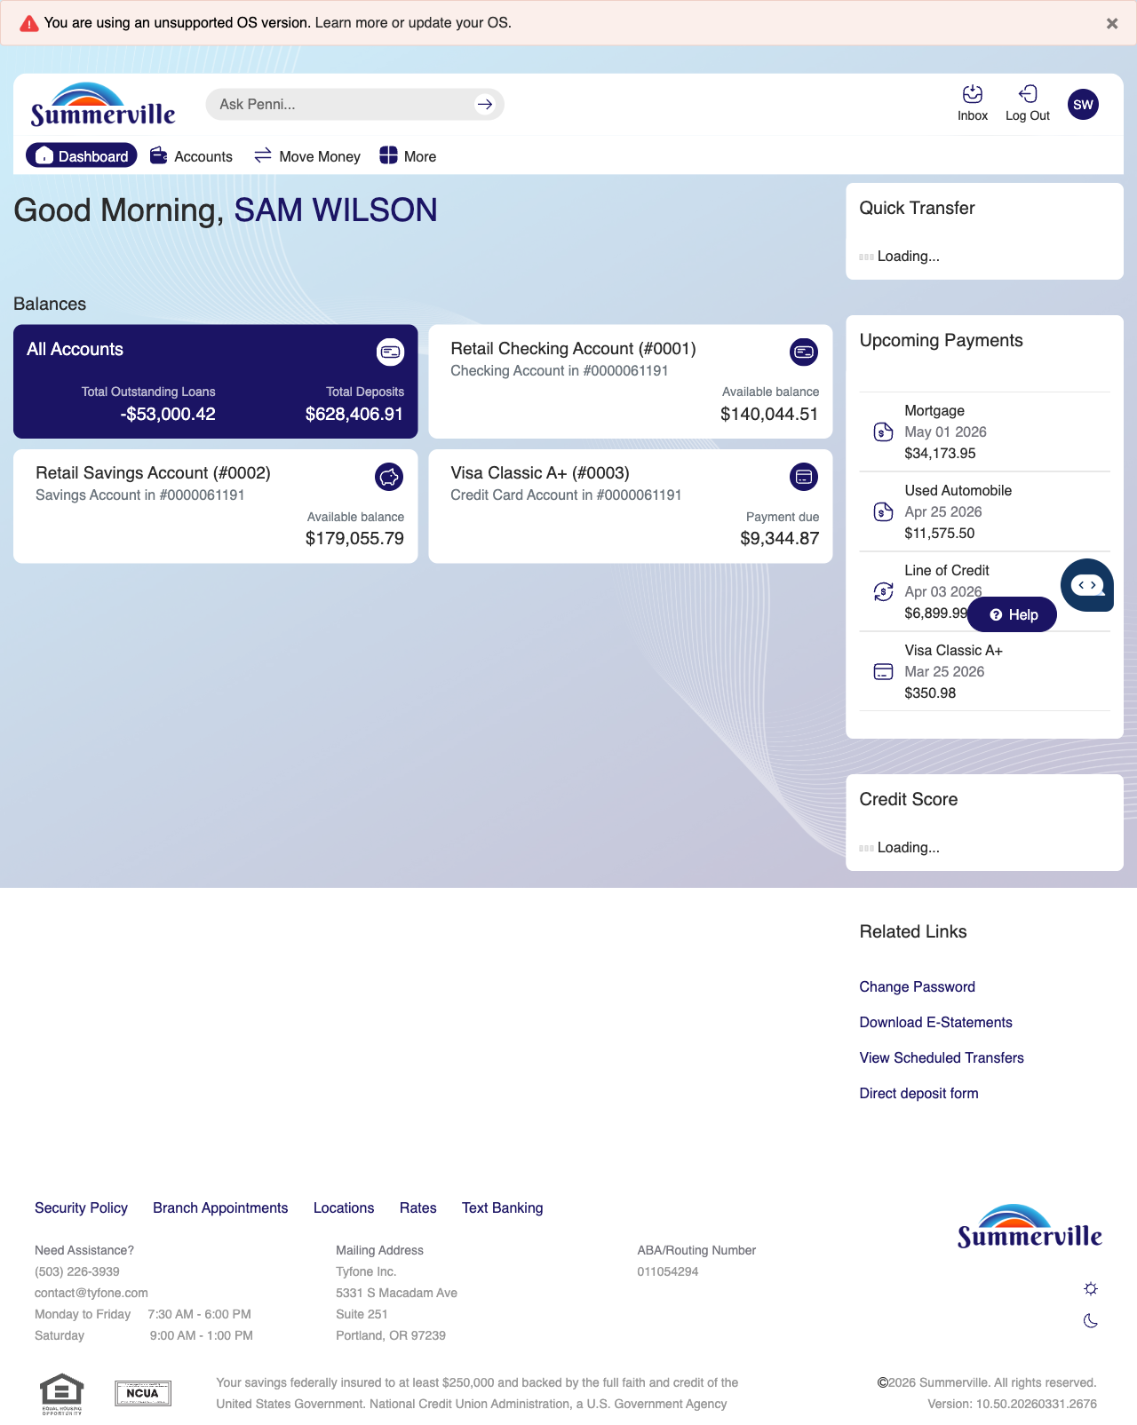
Step 1: Start from the Dashboard

Step 2 — Navigate to Move Money Hub
The member clicks ‘Move Money’ in the top navigation bar. The Move Money Hub displays all payment and transfer options as tiles including Pay Bills, Quick Pay, Zelle Payment, Internal Transfers, Other Members, Same-Day Transfers, Send Instantly, Manage Recipients, Add Recipient, Transaction History, Scheduled Transfers, and P2P Transfer.
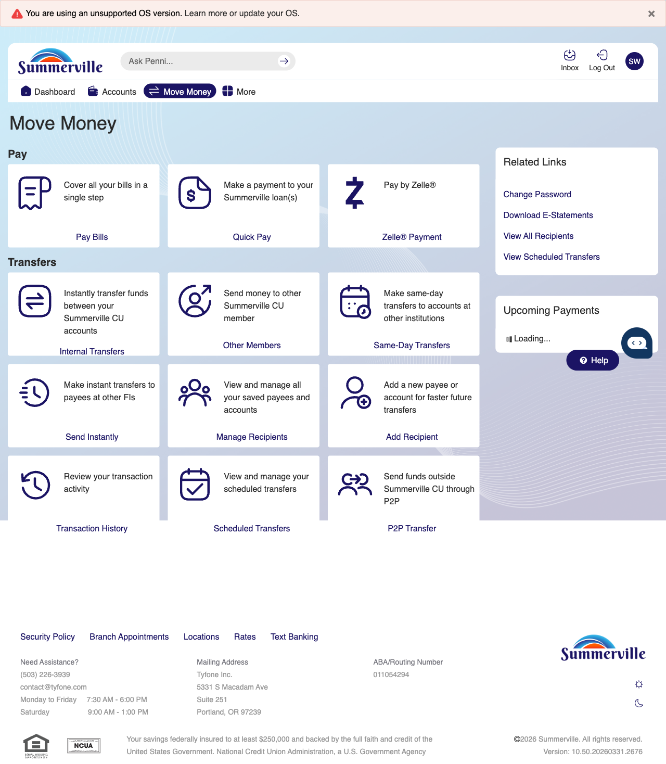
Step 2: Move Money Hub

Step 3 — Navigate from Dashboard to External Transfer
The Move Money hub is displayed as the landing page for initiating an external account transfer.
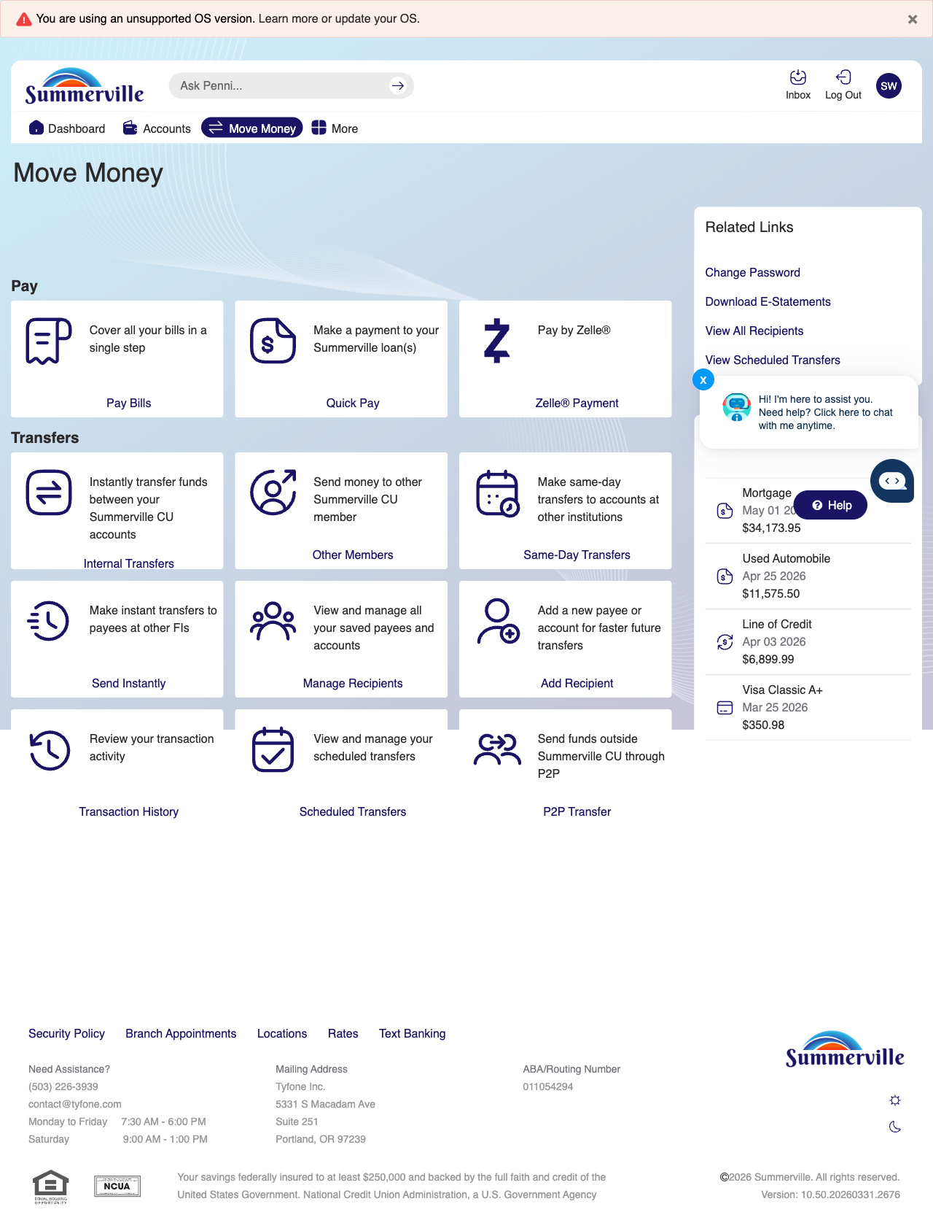
Step 3: Navigate from Dashboard to External Transfer

Step 4 — Fill Transfer Details
Step 2 shows a simplified form with fields for entering the external account transfer details including the destination account information.
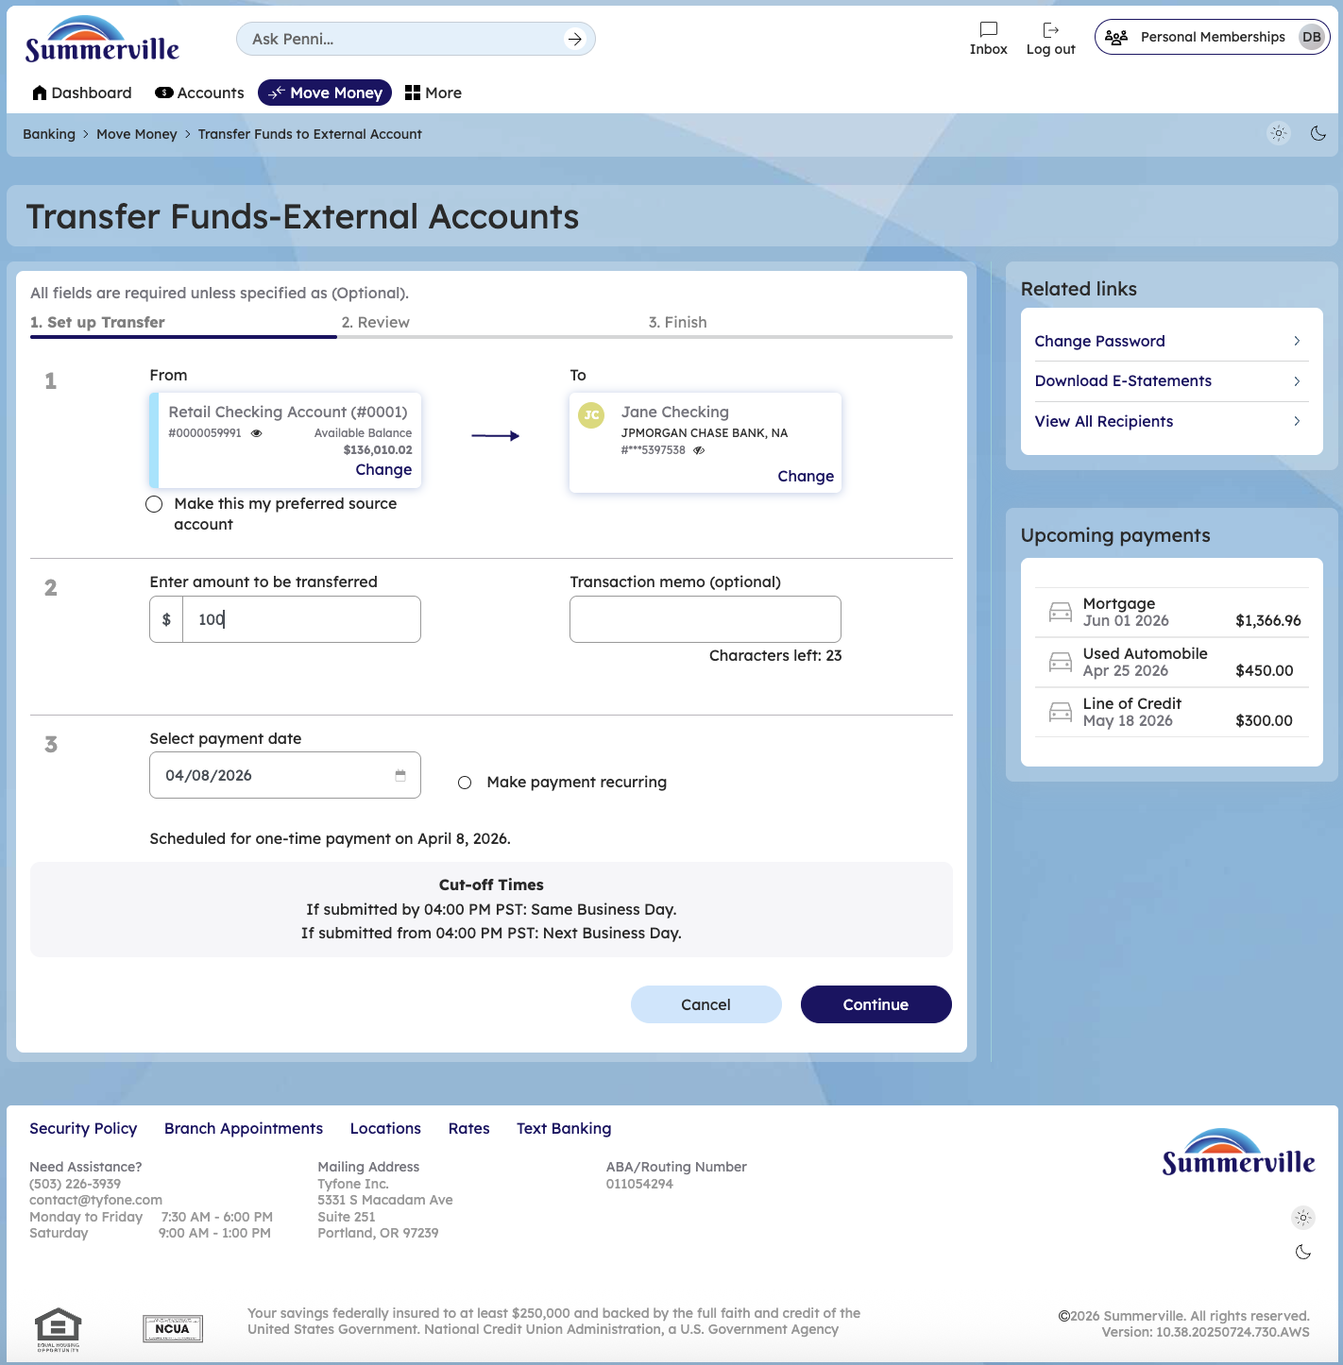
Step 4: Fill Transfer Details

Step 5 — Review Pre-Confirmation
The confirmation screen displays a $5.00 transfer from Retail Savings Account to an external Retail Savings Account, showing the description and scheduled transfer date.
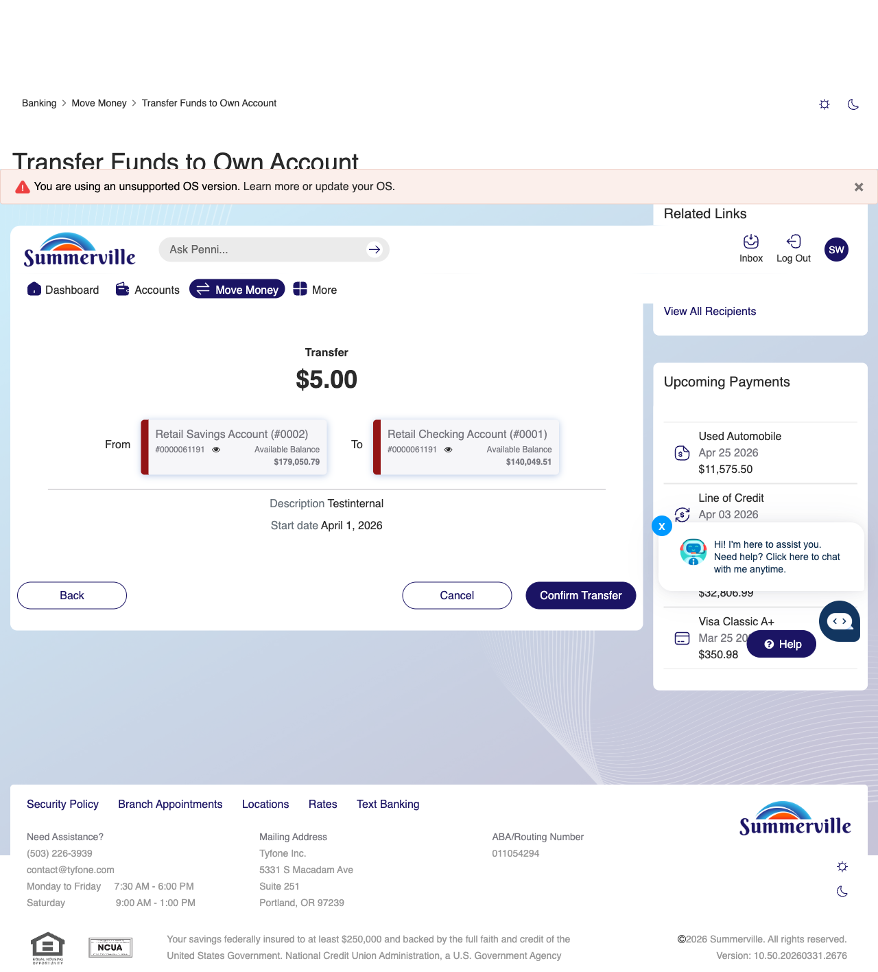
Step 5: Review Pre-Confirmation

Step 6 — Select OTP Verification Method
A verification modal appears offering three authentication methods — 'Send me a message', 'Call me', or 'Send me an email' — to verify the external transfer before processing.
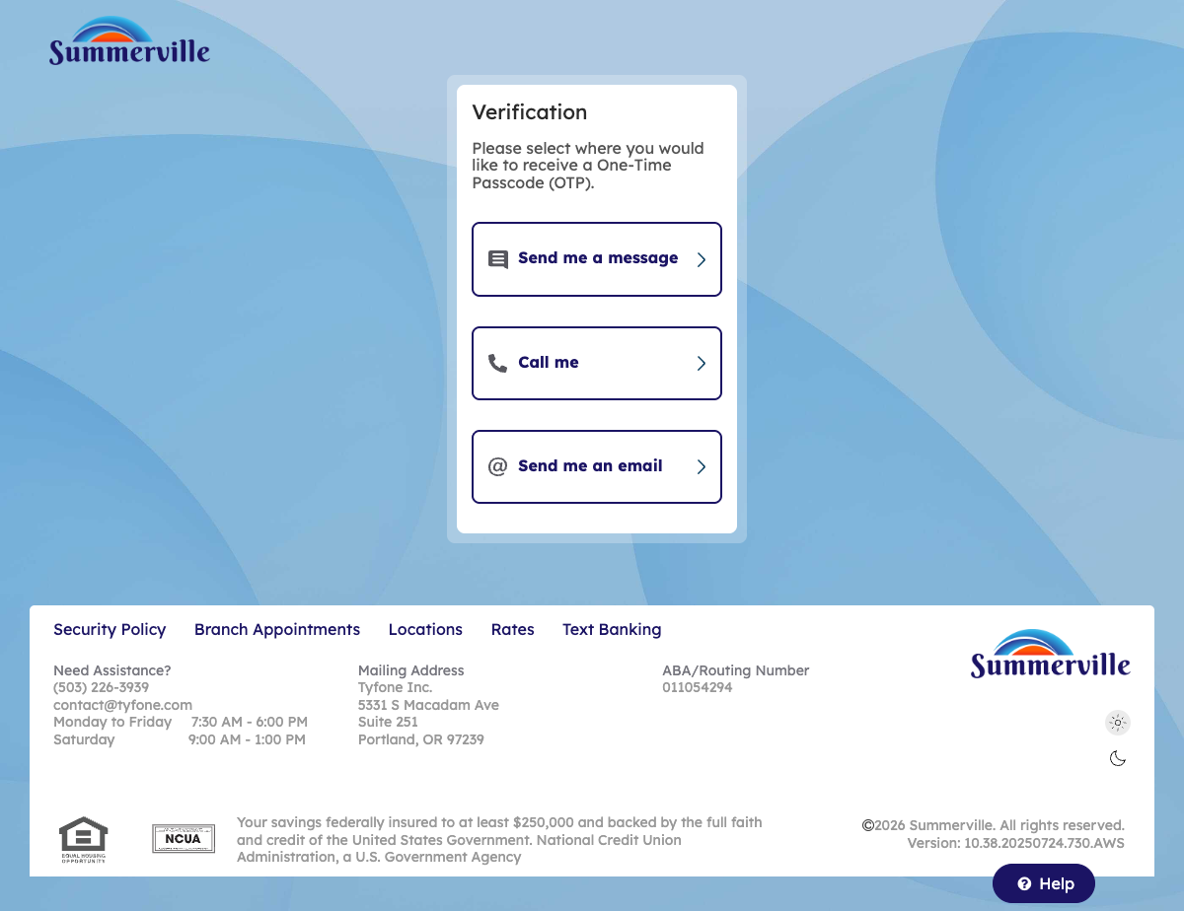
Step 6: Select OTP Verification Method

Step 7 — Enter OTP & Submit
The verification page is displayed with a field to enter the verification code received via the selected authentication method to complete the external transfer.
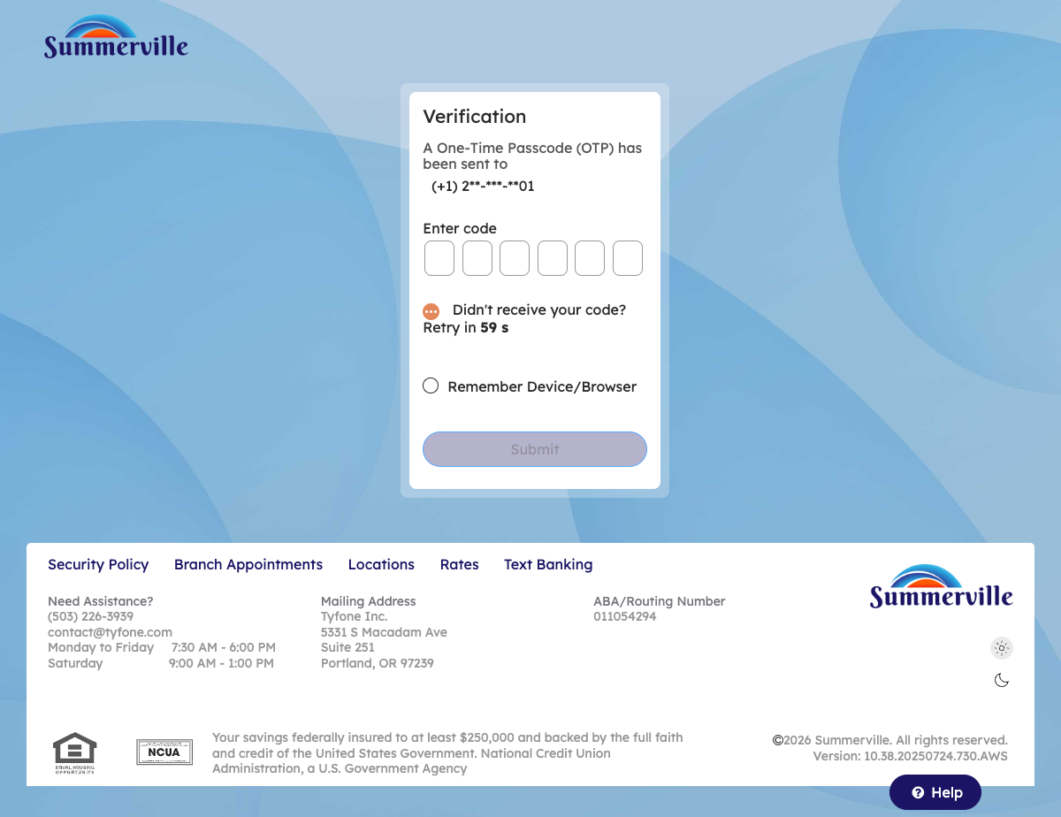
Step 7: Enter OTP & Submit

Scheduled External ACH Transfer Flow
Step 1 — Navigate from Dashboard to External Transfer
The Move Money hub is displayed as the landing page for initiating an external account transfer.

Step 3: Navigate from Dashboard to External Transfer

Step 2 — Schedule a transfer on external ACH transfer
Enter the amount and check a date to schedule the transfer and click on confirm
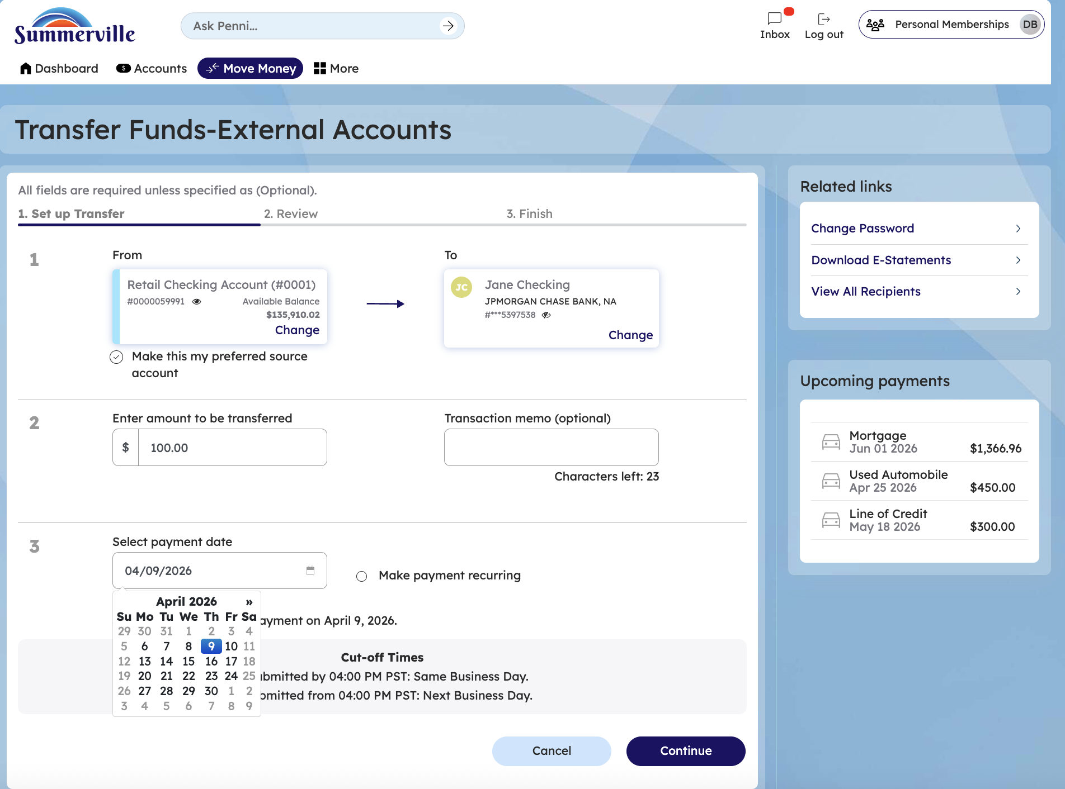
Step 3 — confirm the transfer
Confirm the transfer and recheck the amount and date
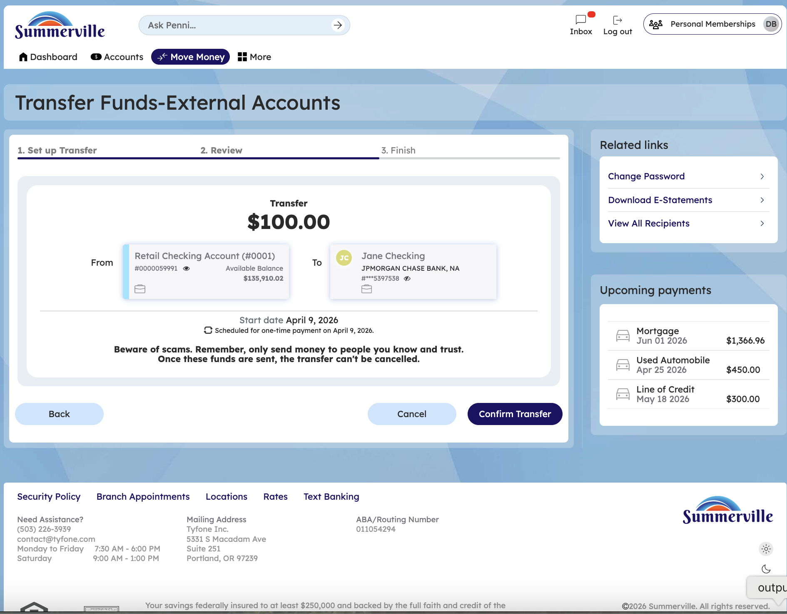
Step 4 — Move back to transfers HUB and go to scheduled transfers
Click on move money hub and click on scheduled transfersStep 4 — Move back to the Transfers HUB and navigate to Scheduled Transfers

After completing the previous steps, click on the Move Money Hub option in the navigation menu. Once on the Move Money Hub screen, locate and click on the Scheduled Transfers section. This action will display a list of all your scheduled transfers.
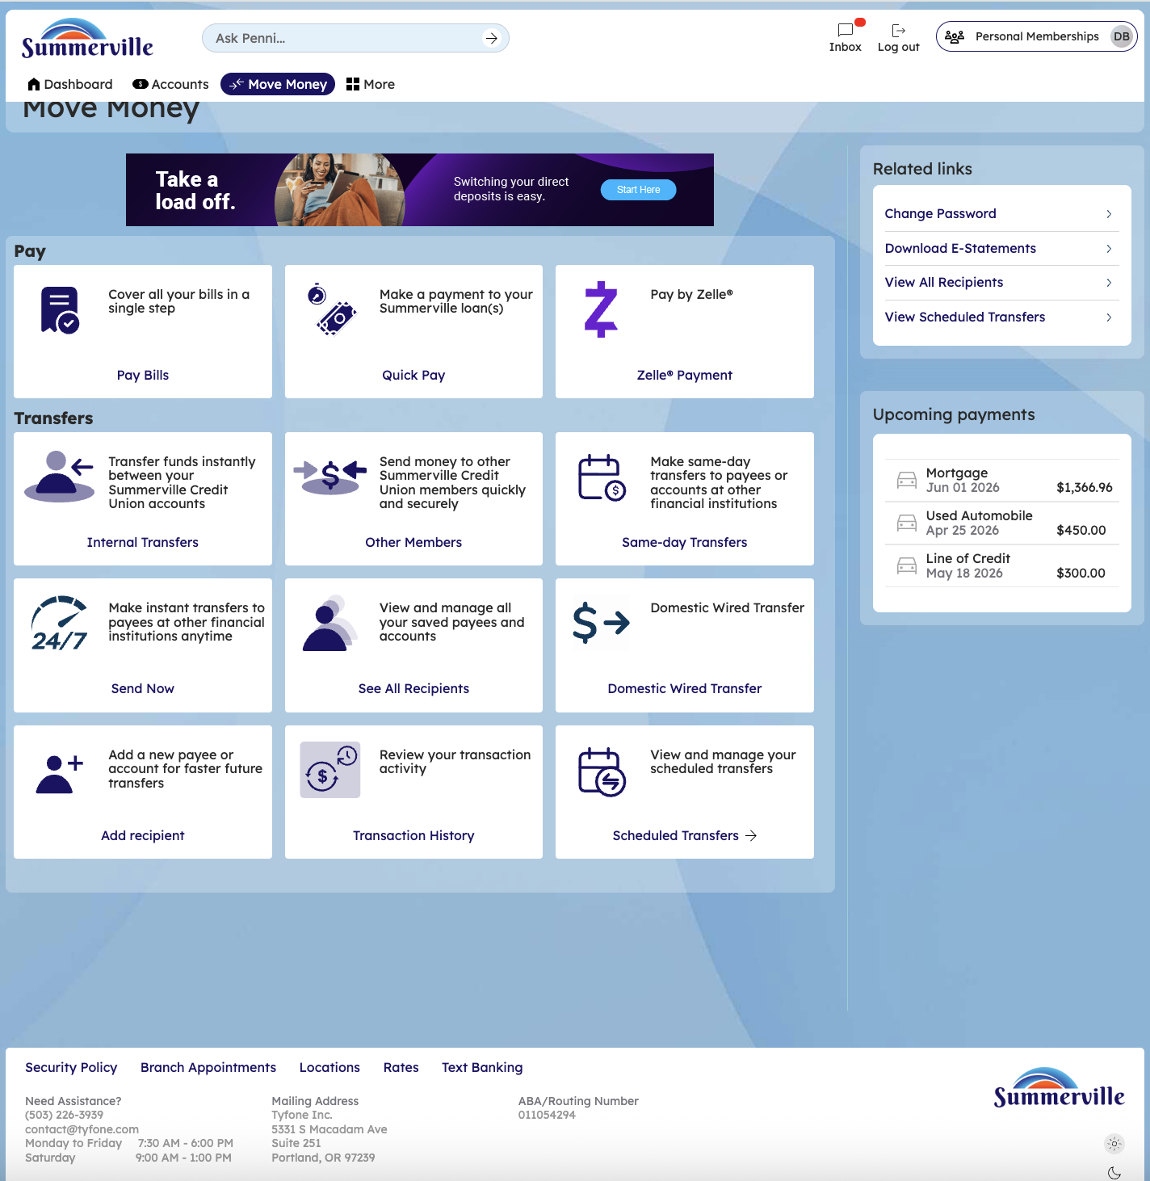
Step 4 — Click on a scheduled transfer
Click on a scheduled transfer and edit or manage the scheduled transfer
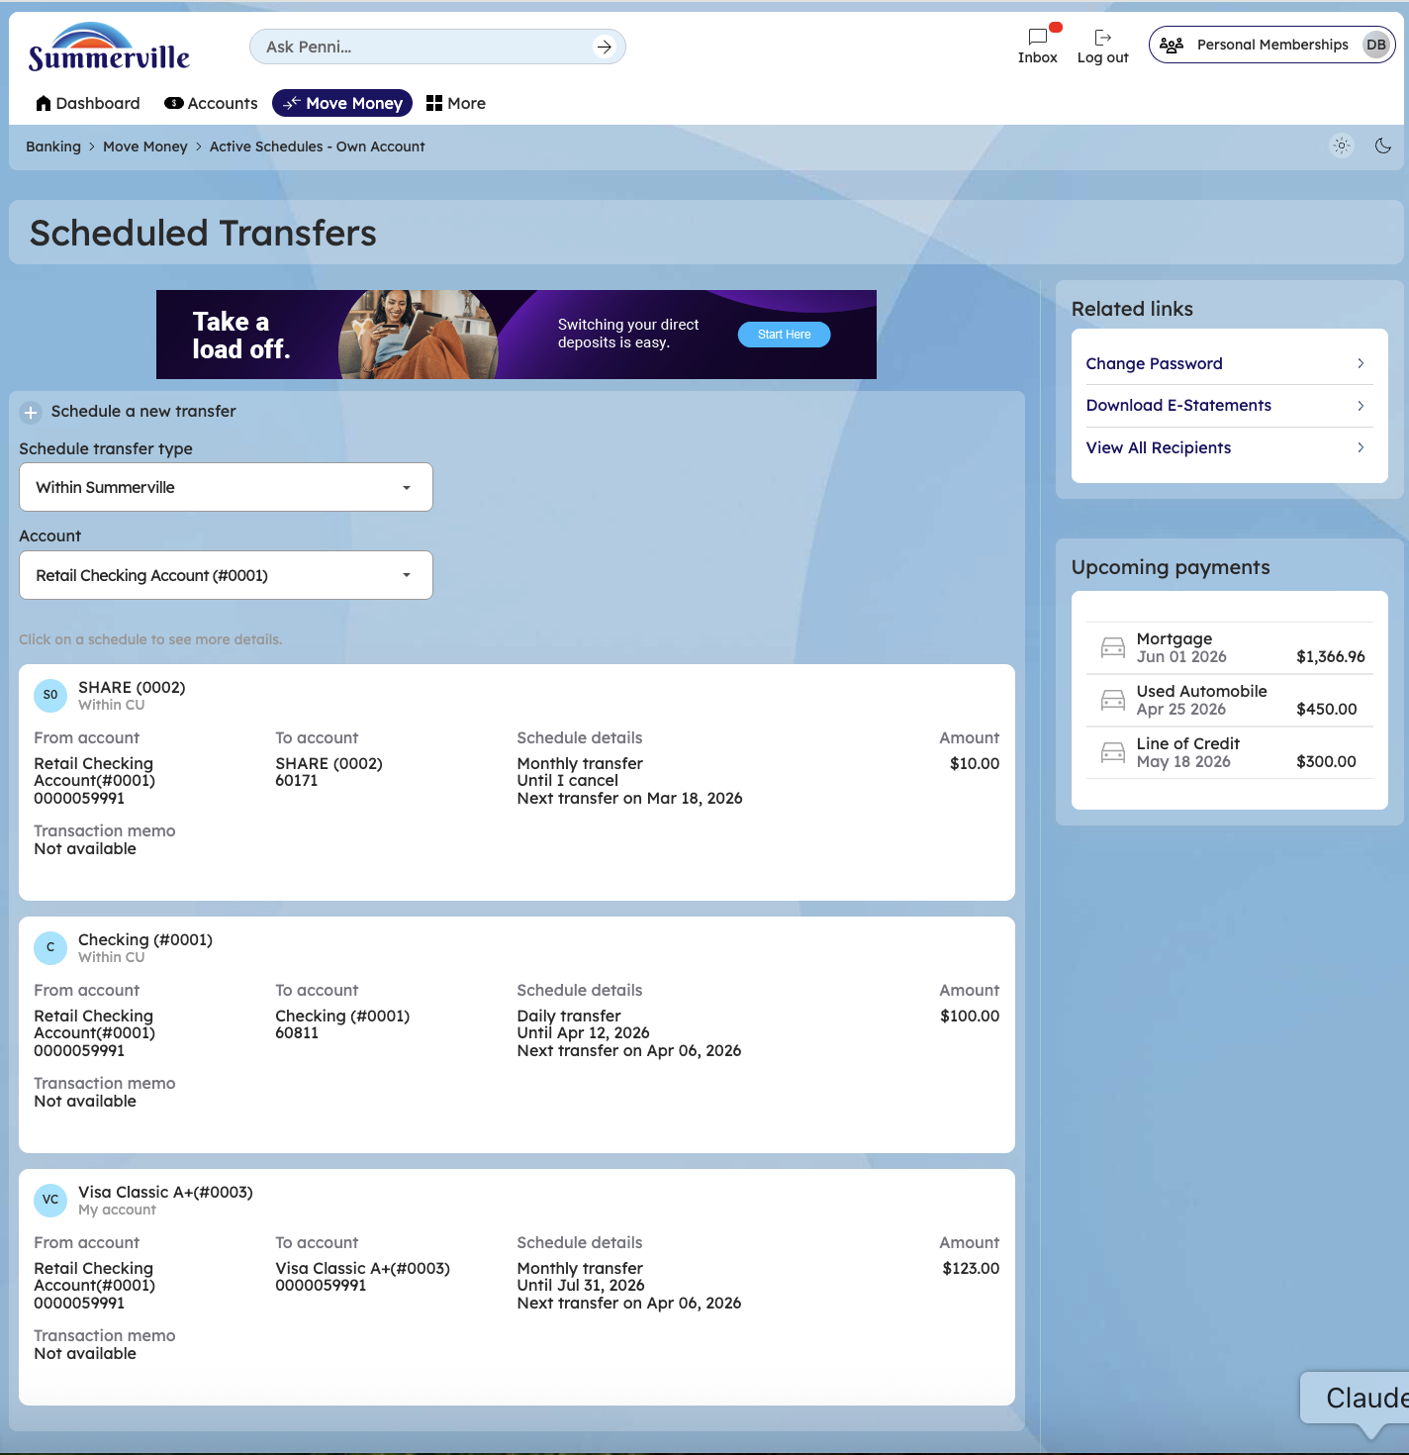
Step 5 — delete a scheduled transfer/edit a scheduled transfer
After clicking on a transfer, view the transfer details and if needed delete a scheduled transferAfter clicking on a specific transfer, the user can view all the comprehensive details of that transfer, including the amount, date, recipient, and status. If the transfer is a scheduled future transfer and has not been processed yet, the user will have the option to delete or cancel the scheduled transfer if necessary/you can also edit scheduler by clicking the edit option
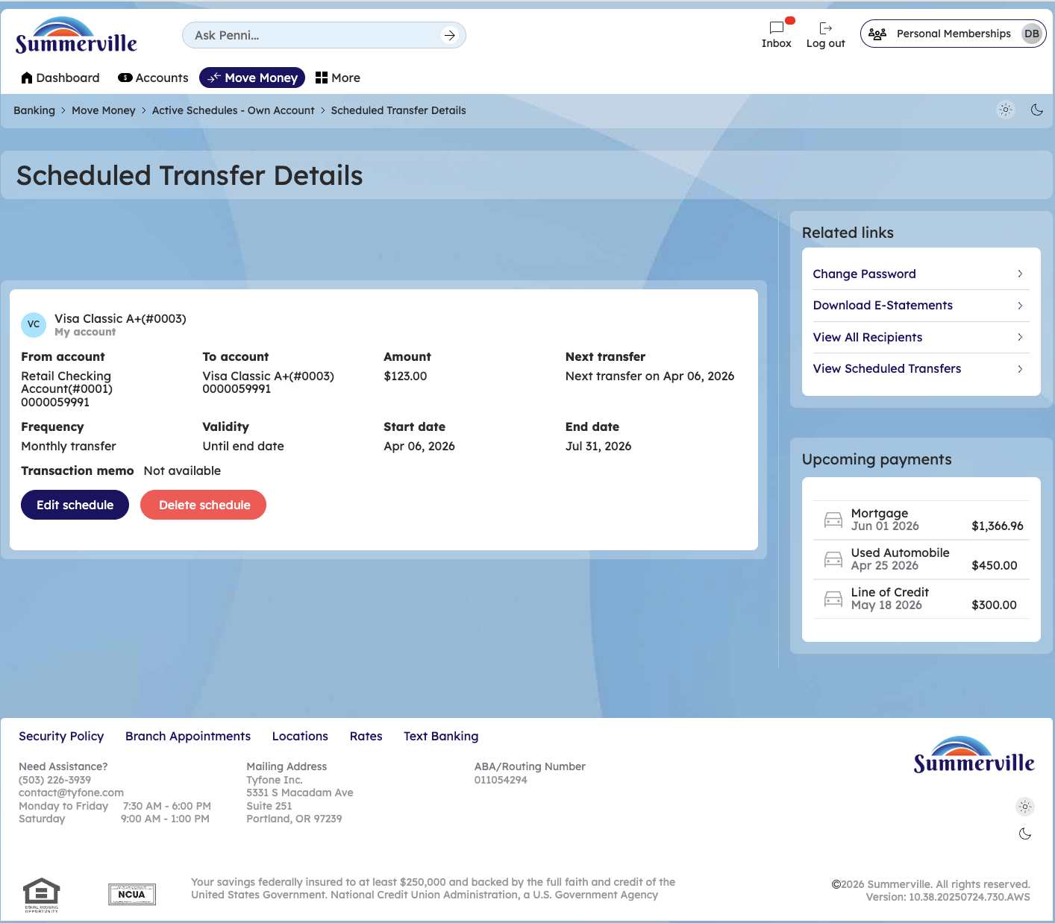

Step 6 — edit a scheduler
After clicking edit scheduler you can edit an existing schedule,make the necessary changes and click o save changes
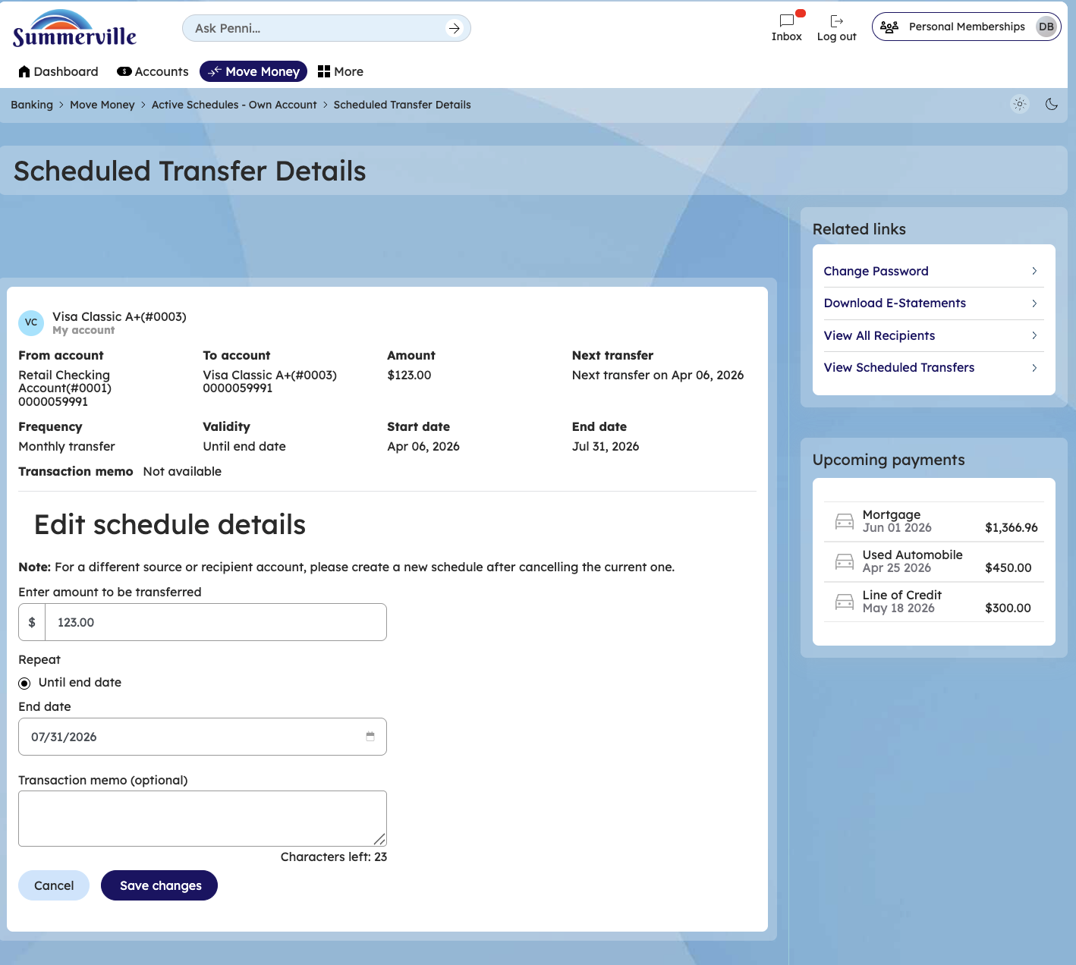
Step 7 — go back to external ACH transfer to make a recurring payment
Enter amount scheduled date and tick the recurring payment option and select a frequency and repeat frequency and select an end date for these recurring payments
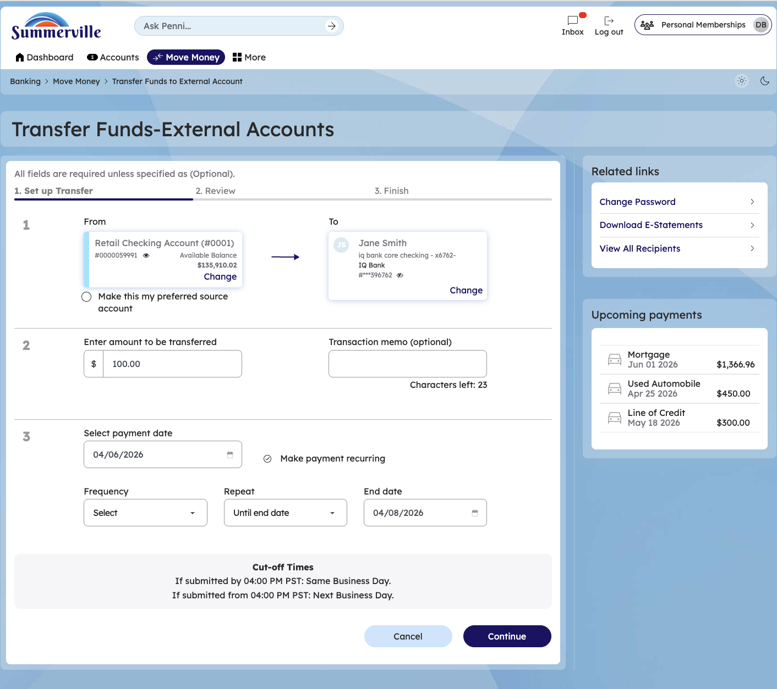
Step 8— confirm the transfer
Confirm the transfer and recheck the amount and date
